Pinball Assembly Instructions

This document contains information about how various mechanicals should be attached to the playfield. It is not an exhaustive set of instructions**. When the order of assembly is important, numbered steps will be provided**; otherwise, bullets will be used.

It is assumed that the playfield and wood extrusions have already been painted and decorated.

Initial Steps

The order of the initial steps is important. We want to determine if any modifications to the playfield or wood extrusions need to be made before we start attaching too many of the mechanisms.

1. Attach to the top of the playfield all mechanisms that require cutouts in the wood extrusions, such as one-way ball gates and spinners.
2. Attach the wooden extrusions to the playfield. Modify the extrusions as necessary to fit over the parts attached in Step 1.
3. Attach the posts required for elastic bands. Test fit the elastic bands. If a band is too loose, add another post inside the band and position it to stretch the band to the desired tension. Mark the position of the new post, drill a 1/8" hole though the playfield at that position, and attach the new post to the playfield.
4. Remove the elastic bands for now, so they do not get in the way.
5. Each pop bumper has three long nail-shaped screws that need to be nailed through the top surface of the playfield. **You must support the playfield adequately while you are nailing, or it will crack**.
6. Mount the playfield in its cradle and secure it in place.
7. Attach the return lane guides.

Attach the Mechanisms

The mechanisms can be attached in any order that you wish. For most of the mechanisms, use #8 × 1/2" screws to attach the mechanism to the bottom of the playfield. The only intricate installation is the pop bumpers, described below.

Pop Bumper Assembly

Pop bumpers have a lot of parts that need to be attached in the correct order. Here is a video showing how the various parts fit together: <https://youtu.be/5YjmaDIFFCo>

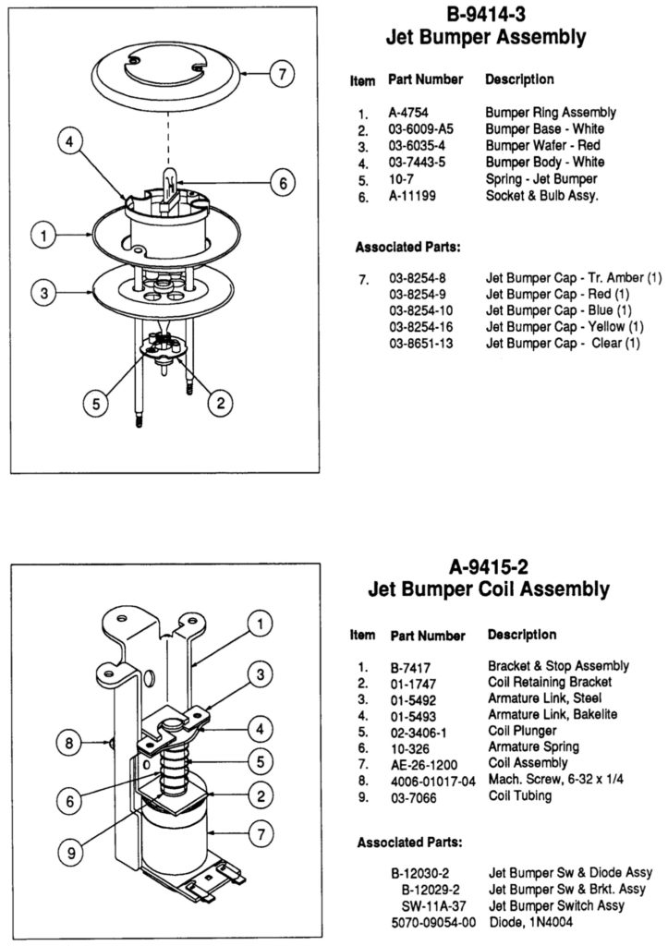

1. You should have already nailed the three large screws through the playfield. Attach the solenoid assembly using those three screws and nylon insert lock nuts.
2. If Part #7, the Bumper Cap, is screwed to the bumper body, unscrew it and set the parts aside.
3. Remove Part #6, the Socket & Bulb Assembly, from the bumper body.
4. Insert Part #2, the Bumper Base, in the central hole on the top of the playfield. The bumper base must be oriented so two (opposing) semi-circular cutouts are aligned with the two satellite holes and the tall screw posts are located over the screw holes in the playfield.
5. Place the spring into the center depression of the bumper base.
6. Insert Part #3, the Bumper Wafer, through the center hole of the bumper base.
7. Align Part #4, the Bumper Body, with the tall screw posts in the bumper base. Affix the bumper body using the supplied screws.
8. Insert Part #1, the Bumper Ring Assembly, over the bumper body and through the bumper wafer and the two satellite holes. Screw the ring assembly to the solenoid assembly.
9. Thread the wire leads on the socket & bulb assembly through the holes in the bumper body and on through the playfield.
10. If you are including a BrightCaps EVO bumper lighting module, now is the time to install it.
11. Attach the bumper cap to the bumper base.

Part Identification Guide

1-Bank Drop Target Assembly

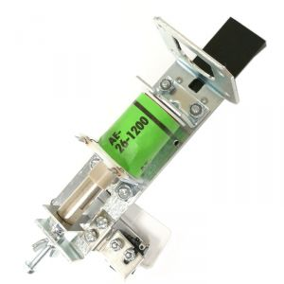

EVO Bright-Caps Bumper Lighting

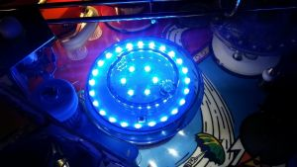

Finned Star Post

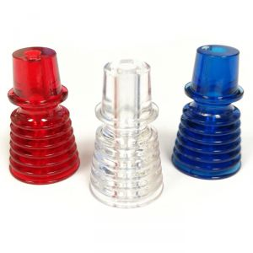

Flipper Assembly (note there are left and right assemblies)

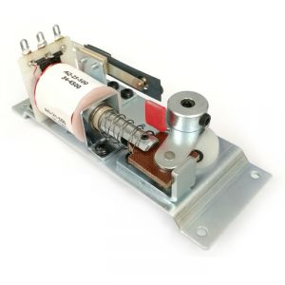

Flipper Bat

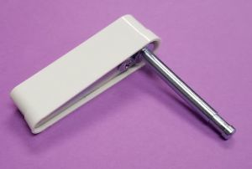

One-Way Ball Gate (note there are left- and right-hand gates)

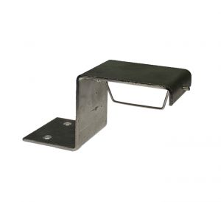

Narrow Plastic Post

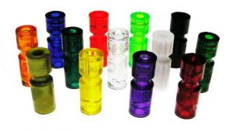

Pop Bumper Assembly

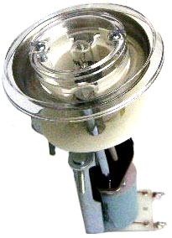

Return Lane Guide

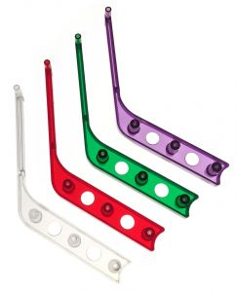

Rollover Switch Assembly

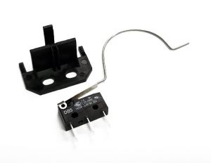

Shooter Assembly

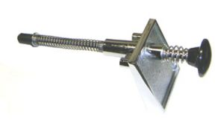

Slingshot Assembly

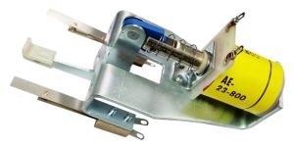

Spinner Assembly

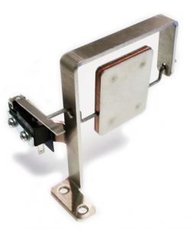

Stand-Up Target

